**Learning about urban mitigation solutions**

William F. Lamb, Felix Creutzig, Jan C. Minx, Max C. Callaghan

**IPCC and related communities put increasing emphasis on cities, suggesting that urban settlements could lead the way in climate change mitigation and provide a test-bed for policy experiments and social change. While an underlying coherent understanding of solutions and opportunities remains fragmented, there is already a large body of case studies literature to learn from and translate into different urban contexts** 1**. However, a number of practical and conceptual challenges stand in the way. First, the literature tends to focus on cases in large, wealthy and globally connected cities, despite the majority of the global population residing in much smaller agglomerations. Second, a comprehensive overview of which mitigation topics have been researched for what cities is currently lacking. Third, secondary analysis of the case study literature is extremely sparse and does not employ structured methods. Here we perform a meta-analysis of the literature landscape of case studies on climate mitigation solutions in cities. We find that … Learning about urban mitigation solutions requires more efforts in performing transparent systematic review on generalizable topics, such as spatial scalability, from individual cities and issues to comparative reviews on large set of cities with multiple entangled climate mitigation strategies.**

Cities experience similar dynamics of urbanisation and agglomeration 2, are faced with structurally comparable decarbonisation challenges 3, and are increasingly interconnected through trade, globalisation, and coordinated social or political movements 4,5. The opportunities for comparative research across cities are therefore widely discussed 6,7, with much of the urban climate change mitigation literature dedicated to case studies of local mitigation actions, or horizontal comparisons of actions across a small number of cities. Learning from these studies is important to satisfy increasing demands for a solutions orientation in the field 8 and to support the urgent upscaling of efforts required to keep global warming below 1.5°C or 2°C 9.

The 6th Assessment Cycle will again include dedicated chapters on urban systems, in both Working Groups II and III. Urban assessments and research networks are in their infancy, but gaining momentum, as exemplified by the Urban Climate Change Research Network (UCCRN, ICLEI), and in renewed efforts to foster a global urban science 10. Case studies are prominent in these assessments: often they are presented in dedicated boxed sections (IPCC, ARC3.2), are curated in libraries of urban initiatives (ICLEI), or are simply placed in the text as examples of policies and actions. But despite their importance to narrative flow and showcasing feasible actions, individual cases can have an ambiguous scientific role – often they tend towards ‘success stories’ rather than failures, favour description over analysis, and lack claims of generalisability. There is little evidence that we are learning from these studies and applying their lessons to other contexts.

Multiple issues in the underlying literature confound learning about urban mitigation solutions. First, cities are known for their conceptual challenges, including how to systematise urban physical boundaries for comparison 11, or select topics that are ‘urban’ and not simply general social or global processes 2. Second, there is an acknowledged bias towards conducting cases in the global North 2. Third, the published literature on climate change is following an exponential growth trend 8 and the urban mitigation field is no exception 1. This raises the risk that attention will only be paid to highly visible, contentious, or successful examples of urban climate change mitigation – overlooking failures and their opportunities for learning, or studies situated in the global South. Finally, the case study format itself is open to questions of academic rigour and a perceived lack of generalisability, despite its potential for explanatory power and empirical richness 12.

Here we take stock of the case study research on urban mitigation so far, assessing the extent to which these issues remain unresolved and suggest ways forward. Our analysis focuses on three questions: (1) which types of cities do we know about, in terms of population size and global region? (2) What mitigation topics do we know about, for which cities? And (3), what secondary analysis is there of the urban case study research? We identify a rich and varied literature of urban case studies, albeit one with regional and topic biases, and highlight the lack of secondary analysis and learning on these studies.

We obtain a sample of urban mitigation articles using a search query that combines synonyms for “urban” and “mitigation” in the Web of Science and Scopus literature databases (Table 1). Our interpretation of case study research is straightforward: if an article mentions a city name in the abstract or title, we assume it is a case study located in the city (or cities) mentioned. We use the Geonames database of geographic locations to identify city names. Of the approximately 12,918 articles identified in WOS and Scopus using our query, 3,440 directly refer to a city in the abstract or title. Double counting where an article mentions multiple cities, we obtain 4,730 case studies. We extract citation information from these databases, in order to observe which types of cities are well referenced in the literature. We divide citations equally among cities in double-counted articles.

|  |  |
| --- | --- |
| Urban synonyms | Mitigation synonyms |
| ("urban*" OR "municipal" OR "city" OR "cities" OR "metropolitan") | (“low carbon” OR "decarboni*ation" OR (“energy” OR “carbon” OR “CO2” OR “GHG” OR “greenhouse gas” OR “climat*”) NEAR/3 ("mitigation" OR "reduc*" OR "polic*" OR "governance")) |

Table 1: Search query for urban climate mitigation literature. The two strings are combined with an ‘AND’ operator and entered as a topic search in the Web of Science, and a title-abstract-keyword search in Scopus.

**Size and regional bias in urban cases**

Urban population size is a useful denominator of city type: it distinguishes between a small number of familiar ‘mega-cities’ (over 10m inhabitants), dozens of smaller national and regional capital cities (5-10m, 1-5m), and hundreds of yet smaller agglomerations. Figure 1 shows a spread of case study research across these different city types. The majority of research focuses on medium and large cities, with a small number of mega-cities receiving particular attention: Beijing (284 articles), New York (146), Shanghai (140) and London (117). Other cities are mentioned in fewer than 100 articles each.

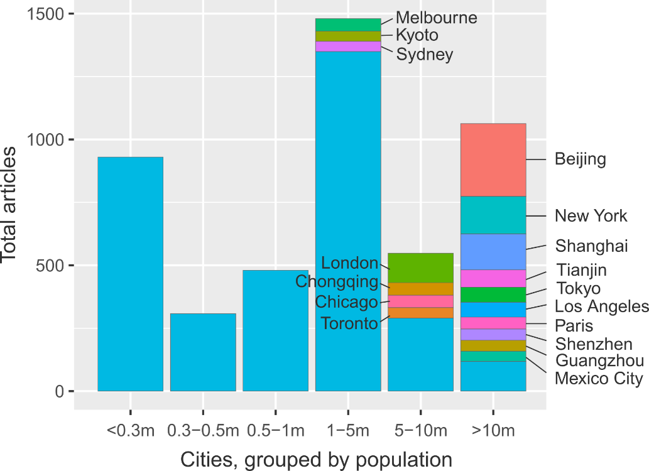

Figure 1: Summed urban climate mitigation articles, grouped according to city size. Where available, urban agglomeration data is used. Cities with more than 40 articles are identified.

Considering the global population distribution across these different city types, is the current focus of research justified? Figure 2 shows, by region, the proportion of articles, article citations and inhabitants for each size of city. Worldwide, we observe a bias towards research on larger cities over smaller cities. These results are most stark in Asia, where articles on mega-cities account for almost x% of all studies and gather x% of citations, relative to smaller cities. In stark contrast to the predominant focus of research, Asia has a very comparativley low proportion of mega-city inhabitants (10%), and a high proportion of inhabitants living in small agglomerations of less than 0.3m persons (33%). Similar mismatches can be seen in Europe, Latin America, North America and Oceania. Moreover, in some cases citations patterns can exacerbate the literature bias – exaggerating the influence of studies on large cities and downplaying the importance of small cities, even where the literature is available (for instance in Europe, where x% of articles refer to small cities, but receive only x% of citations in the region).

Figure 2: Regional size and citation biases in urban mitigation case study research

Regionally, there is a clear bias towards Europe and North America, which receive an outsized share of articles and an even greater share of citations relative to their small proportion of the global urban population (SI Text Fig 1). The opposite trends prevail in Asia, Latin America and Africa, which are systematically under-studied and under-citied in the literature.

In sum we demonstrate someOur analysis reveals clear biases in the urban case study research: larger cities in Europe and North America tend to be favoured in analysis, as well as a small number of specific mega-cities. Citations follow suit and even exacerbate inter-city and inter-regional differences. Our sample of studies captures some non-English language articles (180 in total), but certainly not all; nor does it capture grey literature such as NGO reports. Nonetheless, the results clearly reflect a global division of scientific labour and resonate with wider struggles to situate developing country authors and research in the IPCC assessments.

Urban growth in the 21st century will take place in small and medium-sized cities in Asia and Africa (SI Text Fig 1; UN projections) – precisely the cities on which we lack research. Locating research efforts, stakeholder engagement and policy advocacy in these regions will be instrumental to avoiding lock-in and realising compact, low-carbon urban forms that can tackle the coming mitigation challenge 13,14.

**What topics do we know about?**

What are key topics in cities? Demand-side stuff, well-being stuff, infrastructure lock-in stuff.

As the literature expands it becomes progressively more difficult to grasp the overall topic space of a scientific field. This is particularly the case for the urban studies, where a diverse array of topics are divided among various epistemic communities 1. We therefore turn to natural language processing methods to outline the scope of mitigation research being carried out on cities. Using the identified case studies we construct a matrix of documents and the words they contain (abstracts only), factorising to obtain the ‘topics’ that describe commonly co-occurring words across the document set (see methods). In essence, machine reading software discovers the latent themes that permeate the document set and categorises each document accordingly, substituting for the laborious task of reading and tagging each article by hand. Moreover, the unsupervised ‘learning’ of the topics reduces subjectivity in the choice of categories (see methods for details).

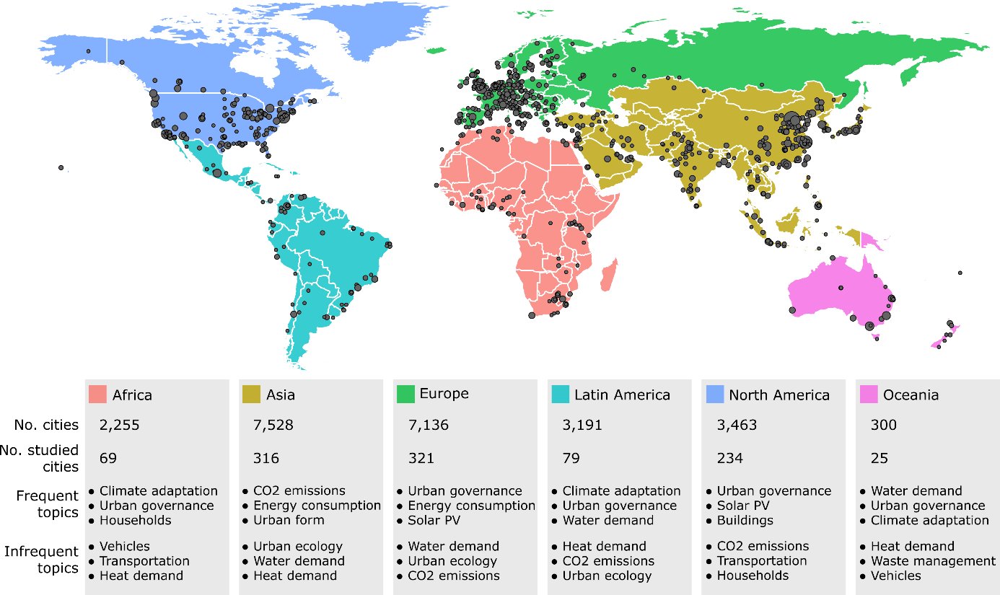

Figure 3: Urban case study cities and topics by region

We isolate 17 broad topic areas in the set of case studies (SI Text Table 1). As might be expected this includes topics on urban governance, urban form, energy consumption, and CO2 emissions accounting in cities. A tendency towards demand-side climate mitigation topics can be observed, including transportation, waste management and end-use energy and heat demand in buildings and households. A single supply-side topic is present: on solar PV. The presence of topics on air pollution, water demand, urban ecology and climate adaptation highlights the integration of climate mitigation with wider sustainability issues in cities.

Overall this topic space is well aligned to discussions in the literature, situating the urban context as the site of everyday energy use via behaviours, practices and infrastructure provisioning – and hence the locus of demand-side mitigation measures 15,16. It also confirms that the urban literature, and case studies more specifically, are directly addressing clusters of issues at the heart of the 2030 Agenda for Sustainable Development, e.g. on vehicles, mobility and human health (REF); or urban governance practices for mitigation and adaptation (REF).

Regional divisions in topics might be expected from the literature. Figure 3 lists the frequently and infrequently occurring topics by region, bearing this out. For instance, the topic of urban governance, which captures policies and policy-making, is prevalent in all regions with the exception of Asia, where studies focus instead on CO2 emissions accounting and structural issues of urban form. We also observe regional variations in adaptation focus (Africa, Latin America and Oceania), supply-side studies (Europe, North America), …

[Paragraph on scenario words].

**Fragmented case comparisons, few formal reviews**

Comparative urban research is key to generating broader insights from individual cases – and for compensating for lacking knowledge on particular cities, regions and topics. Cities are known to provide fertile ground for comparison: they experience similar dynamics of urbanisation and agglomeration 2, are faced with structurally comparable decarbonisation challenges 3, and are increasingly interconnected through trade, globalisation, and coordinated social or political movements 4,5. We therefore expect to see a sizable portion of the case study literature dedicated to comparing and contrasting urban experiences.

Approximately 25% of the case studies we identify have a comparative orientation – insofar as they refer to more than one city in the abstract. There is a broadly even spread of comparative research across regions and agglomeration sizes. The direction of comparisons, however, are typically limited to within global regions: European cities, for instance, are most often compared to other European cities. Only X studies draw comparisons across regions, with the major couplings being North America and Europe (115 studies), Europe and Asia (107 studies), and North America and Asia (99 studies), while South-South comparisons are fewer (e.g. between Asia and Africa: 21 studies).

Comparisons of two or three cities are the norm (SI text Fig). A small number of studies survey 5 or more cities, often deploying quantitative methods (for instance to compare urban GHG emissions, technology costs, or sustainability indices), although we also find descriptive policy reviews of multiple cities (REFs). Overall, the limited extent of inter-regional comparative research and large-scale case surveys suggests that the field has yet to mature into a global urban science.

Beyond case to case comparisons, literature reviews are key to learning across the field. Formal review methods – those that deploy transparent and systematic procedures for literature selection, quality assessment and synthesis – are the gold standard for generating a robust evidence base for policy 18,19. A wide spread of quantitative, qualitative and mixed formal review approaches are available and well-documented, primarily in the health sciences literature 20. Again, however, we find limited progress on this front.

Searching the original document set identified in Table 1, just 10 studies can be identified that apply formal methods to the urban mitigation literature (Table 2). The majority of these studies are narrative reviews: akin to a normal literature review, but proceeding from a transparent search and selection of literature. Quantitative synthesis methods are sparse, comprising a single meta-analysis of residential demand-response programs (ref) and two studies that extract and analyse quantitative information from literatures on urban ecosystem services (refs). We do not find a single study referring to formal case study review methods, such as qualitative comparative analysis, case study meta-analysis, or case surveys 21 – although there are examples of these methods being applied directly to urban data (but not to the existing literature) 17.

|  |  |  |
| --- | --- | --- |
| **Authors & year** | **Title** | **Method** |
| Li & Babcock 2014 | Green roofs against pollution and climate change. A review | Narrative review |
| Lwasa et al. 2014 | Urban and peri-urban agriculture and forestry: Transcending poverty alleviation to climate change mitigation and adaptation | Narrative review |
| Brands 2014 | Prospects and challenges for sustainable sanitation in developed nations: a critical review | Narrative review |
| Lwasa et al. 2015 | A meta-analysis of urban and peri-urban agriculture and forestry in mediating climate change | Narrative review |
| Kwan & Hashim 2016 | A review on co-benefits of mass public transportation in climate change mitigation | Narrative review |
| Garcez 2017 | What do we know about the study of distributed generation policies and regulations in the Americas? A systematic review of literature | Bibliometrics |
| Deng et al. 2017 | Co-benefits of greenhouse gas mitigation: a review and classification by type, mitigation sector, and geography | Bibliometrics and narrative review |
| Francis & Jensen 2017 | Benefits of green roofs: A systematic review of the evidence for three ecosystem services | Quantitative synthesis |
| Srivastava, Passel & Laes 2018 | Assessing the success of electricity demand response programs: A meta-analysis | Meta-analysis |
| Song et al. 2018 | The economic benefits and costs of trees in urban forest stewardship: A systematic review | Bibliometrics, quantitative synthesis, narrative review |

**Table 2: Formal reviews of urban climate change mitigation.** The minimum criteria for a ‘formal review’ is the selection of literature via a database search. We identified these studies using the keywords “ meta-“ OR “systematic review” OR “scoping” OR “narrative review” OR “qualitative comparative analysis” OR “QCA” OR “scientometric” OR “synthesis” on the document set from Table 1, followed by hand filtering the results to exclude non-urban, non-mitigation and non-review articles.

**Towards learning about urban mitigation solutions**

- Summary paragraph of results: we identify some obvious biases and deficiencies in the literature. Caveat: our sample of documents is not comprehensive.

- Paragraph on filling the obvious research gaps: focus on smaller cities. Focus on Asia and Africa. Integrate knowledge from fields not directly addressing mitigation concerns. Bibliometric methods used here can keep us up to date on how the field is developing – particularly as it rapidly grows.

- Paragraph on comparative research: a sound logic generalisability is necessary to guide comparative research and structure learning on cities, particularly with large-n samples. Three options are apparent: (1) city is large and geopolitically important, therefore globally relevant (we see quite a lot of this); (2) city shares similar traits with other cities (in terms of physical, political, demographic features), here there is a role for typologies to structure comparisons; (3) the problem at hand is ubiquitous and has common characteristics across most cities (urban form, technical issues, congestion, sprawl effects). We provide examples of such studies below.

|  |  |
| --- | --- |
| **Logic of generalisability** | **Examples** |
| *Intrinsic impact*: a large city with intrinsic global or geopolitical relevance | * Beijing should get a mention |
| *System relevance*: cities share similar structural traits and may learn from one another | * Typology paper * Need a more political science angled paper on urban governance |
| *Problem relevance*: a ubiquitous problem with common characteristics that is shared across many city types | * Air pollution, human health, congestion and mobility. AKA cars and how to get rid of them. |

- Paragraph on reviews: reviews are really difficult for a diffuse case study literature that uses varied methodologies, locations, and scales. At the very least a transparent literature selection is needed to avoid overlooking research. Note that there are case study review methods, for instance to code qualitative and contextual features from cases, and thereby compare and aggregate the conditions across cases leading to successful reforms. The tiny number of formal reviews is really shocking though, but not surprising for our field.

- Again, a focus on generalisability helps to structure reviews: we see many anecdotes of individual big cities, but no comprehensive reviews of these cities. This would be needed to evaluate the robustness of outcomes, and to grasp the broader sustainability implications of a given reform. Similarly, a structured comparison of policy implementation and outcomes across multiple cases may reveal which contextual traits are key to driving outcomes, hence telling us which kinds of cities will learn from experiences elsewhere. And reviews of ubiquitous problems (e.g. congestion) coupled with assessments and meta-analyses of existing solutions (congestion charging, parking prices, public transport provisioning…) are highly salient for policy and help push issues up the agenda.

- Paragraph on assessments: ??

1. Lamb, W. F., Callaghan, M. W., Creutzig, F., Khosla, R. & Minx, J. C. The literature landscape on 1.5°C Climate Change and Cities. *Curr. Opin. Environ. Sustain.* **30,** 26–34 (2018).

2. Scott, A. J. & Storper, M. The nature of cities: The scope and limits of urban theory. *Int. J. Urban Reg. Res.* **39,** 1–15 (2015).

3. Creutzig, F., Baiocchi, G., Bierkandt, R., Pichler, P.-P. & Seto, K. C. Global typology of urban energy use and potentials for an urbanization mitigation wedge. *Proc. Natl. Acad. Sci.* (2015). doi:10.1073/pnas.1315545112

4. Sudmant, A., Gouldson, A., Millward-Hopkins, J., Scott, K. & Barrett, J. Producer cities and consumer cities: Using production- and consumption-based carbon accounts to guide climate action in China, the UK, and the US. *J. Clean. Prod.* **176,** 654–662 (2017).

5. Global Covenant of Mayors. Global Covenant of Mayors for Climate & Energy. (2017). Available at: http://www.globalcovenantofmayors.org. (Accessed: 10th November 2017)

6. Grandin, J., Haarstad, H., Kjærås, K. & Bouzarovski, S. The politics of rapid urban transformation. *Curr. Opin. Environ. Sustain.* **31,** 16–22 (2018).

7. Bulkeley, H. & Castán Broto, V. Government by experiment? Global cities and the governing of climate change. *Trans. Inst. Br. Geogr.* **38,** 361–375 (2013).

8. Minx, J. C., Callaghan, M., Lamb, W. F., Garard, J. & Edenhofer, O. Learning about climate change solutions in the IPCC and beyond. *Environ. Sci. Policy* **77,** (2017).

9. Solecki, W. *et al.* City transformations in a 1.5°C warmer world. *Nat. Clim. Chang.* **8,** 175–185 (2018).

10. Acuto, M., Parnell, S. & Seto, K. C. Building a global urban science. *Nat. Sustain.* **1,** 2–4 (2018).

11. Bai, X. Industrial Ecology and the Global Impacts of Cities. *J. Ind. Ecol.* **11,** 1–6 (2007).

12. Steinberg, P. F. Can We Generalize from Case Studies? *Glob. Environ. Polit.* **15,** 152–175 (2015).

13. Karen C., S. *et al.* in *Climate Change 2014: Mitigation of Climate Change. Contribution of Working Group III to the Fifth Assessment Report of the Intergovernmental Panel on Climate Change* 923–1000 (Cambridge University Press, 2014). doi:10.1017/CBO9781107415416.018

14. Creutzig, F. *et al.* Urban infrastructure choices structure climate solutions. *Nat. Clim. Chang.* **6,** 1054 (2016).

15. Creutzig, F. *et al.* Beyond Technology: Demand-Side Solutions for Climate Change Mitigation. *Annu. Rev. Environ. Resour.* **41,** 173–198 (2016).

16. Creutzig, F. *et al.* Towards demand-side solutions for mitigating climate change. *Nat. Clim. Chang.* **8,** 260–271 (2018).

17. Nijkamp, P. & Pepping, G. A Meta-analytical Evaluation of Sustainable City Initiatives. *Urban Stud.* **35,** 1481–1500 (1998).

18. Berrang-Ford, L., Pearce, T. & Ford, J. D. Systematic review approaches for climate change adaptation research. *Reg. Environ. Chang.* (2015). doi:10.1007/s10113-014-0708-7

19. Sorrell, S. Improving the evidence base for energy policy: The role of systematic reviews. *Energy Policy* **35,** 1858–1871 (2007).

20. Kastner, M., Antony, J., Soobiah, C., Straus, S. E. & Tricco, A. C. Conceptual recommendations for selecting the most appropriate knowledge synthesis method to answer research questions related to complex evidence. *J. Clin. Epidemiol.* **73,** 43–49 (2016).

21. Newig, J. & Fritsch, O. *The case survey method and applications in political science*. **49,** (2009).

22. Robinson, J. Cities in a World of Cities: The Comparative Gesture. *Int. J. Urban Reg. Res.* **35,** 1–23 (2011).

23. Castán Broto, V. & Bulkeley, H. A survey of urban climate change experiments in 100 cities. *Glob. Environ. Chang.* **23,** 92–102 (2013).

24. Reckien, D. *et al.* Climate change response in Europe: What’s the reality? Analysis of adaptation and mitigation plans from 200 urban areas in 11 countries. *Clim. Change* **122,** 331–340 (2014).

25. Heidrich, O., Dawson, R. J., Reckien, D. & Walsh, C. L. Assessment of the climate preparedness of 30 urban areas in the UK. *Clim. Change* **120,** 771–784 (2013).

**Supplementary information**

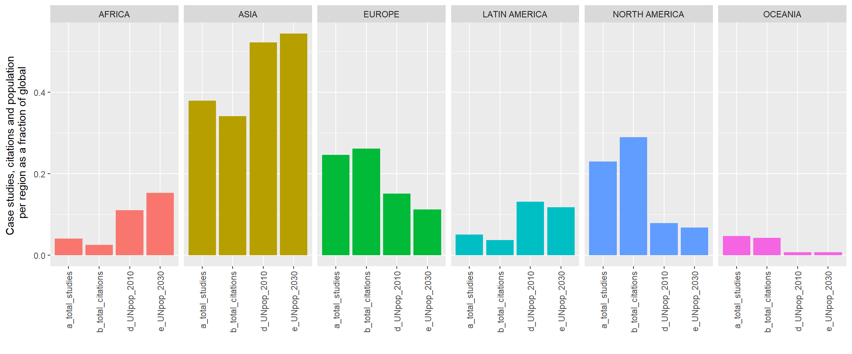

Fig 1: Regional biases in urban case study research and citations

|  |  |  |  |
| --- | --- | --- | --- |
| **ID** | **Topic Name** | **Stemmed Keywords** | **Marginal Topic Distribution** |
| 1 | Urban governance | citi; polici; govern; local; develop | 9.3 |
| 2 | Energy consumption | energi; consumpt; effici; sector; beij | 7.9 |
| 3 | Urban form | urban; area; land; ecolog; model | 7.2 |
| 4 | Solar PV | system; solar; power; electr; energi | 7.0 |
| 5 | CO2 emissions | carbon; emiss; industri; china; lowcarbon | 6.8 |
| 6 | Buildings | build; design; energi; perform; residenti | 6.8 |
| 7 | Climate adaptation | climat; chang; adapt; risk; govern | 6.5 |
| 8 | Air pollution | air; pollut; health; qualiti; concentr | 6.2 |
| 9 | Transportation | transport; travel; traffic; public; car | 5.7 |
| 10 | GHG emissions | ghg; emiss; greenhous; gas; reduct | 5.4 |
| 11 | Vehicles | vehicl; electr; fuel; drive; emiss | 4.8 |
| 12 | Households | household; incom; electr; survey; hous | 4.7 |
| 13 | Waste management | wast; landfil; solid; manag; msw | 4.6 |
| 14 | Water demand | water; suppli; manag; demand; treatment | 4.6 |
| 15 | Heat demand | heat; district; thermal; demand; network | 4.6 |
| 16 | Green roofs | roof; temperatur; cool; green; surfac | 4.5 |
| 17 | Urban ecology | tree; forest; plant; speci; sequestr | 3.4 |

Table 1: List of topics and their keywords

Table of comparative studies

Figure of regional comparisons